System and Software Architecture Description (SSAD)

XL2
Team No. 10

Name | Primary Role | Secondary Role
Kevin Crimi | Prototyper, Builder | Feasibility Analyst
Sindhu Nachimuthu | Project Manager, Life Cycle Planner | Builder
Ritesh Nanda | Operations Concept Engineer | Reviewer, Tester, Trainer
Muthukumaran Dhanapal | Software Architect, Builder | Feasibility Analyst
Ted Lee | IIV & V, Tester, Quality Manager | Project Manager

Version History
Date | Author | Version | Changes made | Rationale
10/13/12 | Muthukumaran Dhanapal | 1.0 | - Original template | - Initial draft
10/15/12 | Kevin Crimi | 1.0 | - Changed System Context Section  - Changed Artifacts and Information Section  - Changed Behavior and Processes Section | - Changed to closer match the template  - Generated new diagrams using Visual Paradigm
10/20/12 | Muthukumaran Dhanapal | 1.1 | - Template with section 1 updated | - Document for Draft FCP
10/29/12 | Muthukumaran Dhanapal | 1.2 | - Changed System Context Section  - Changed Artifacts and Information Section  - Changed Behavior and Processes Section | - Generated new diagrams using Visual Paradigm
11/3/12 | Muthukumaran Dhanapal | 2.0 | - Changed the SSAD to architected agile template  - Completed section 2, 3 and 4 | - Document for DCP
11/14/12 | Muthukumaran Dhanapal | 2.1 | - Updated Section 2, 3 and 4 | - Updated SSAD with IV&V inputs
11/24/12 | Muthukumaran Dhanapal | 3.0 | - Updated Section 1, 2 and 3 | - Document for Draft TRR

Table of Contents
System and Software Architecture Description (SSAD) i
Version History ii
Table of Contents iii
Table of Tables iv
Table of Figures vi
1. Introduction 1
1.1 Purpose of the SSAD 1
1.2 Status of the SSAD 1
2. System Analysis 2
2.1 System Analysis Overview 2
2.1.1 System context 2
2.1.2 Artifacts and information 3
2.1.3 Behaviour 4
2.1.3.1 Enter asset information into the model 4
2.1.3.2 Produce cash flow analysis 10
2.1.3.3 Track Budgets 11
2.1.4 Modes of operation 11
2.2 System Analysis Rationale 12
3. Technology-Specific System Design 13
3.1 Design Overview 13
3.1.1 System structure 13
3.1.2 Design Classes 14
3.1.2.1 GUI class 14
3.1.2.2 Controller class 15
3.1.2.3 Report generator class 16
3.1.3 Process realization 17
3.2 Design Rationale 17
4. Architectural Styles, Patterns and Frameworks 18

Table of Tables
Table 1: Actors summary 2
Table 2: Artifacts and information summary 3
Table 3: Process description (Set Development phases) 4
Table 4: Typical course of action (Set Development phases) 4
Table 5: Exceptional course of action (Set Development phases) 5
Table 6: Process description (Enter revenue assumptions) 5
Table 7: Typical course of action (Enter revenue assumptions) 5
Table 8: Exceptional course of action (Enter revenue assumptions) 5
Table 9: Process description (Adjust the cost distributions) 6
Table 10: Typical course of action (Adjust the cost distribution) 6
Table 11: Exceptional course of action (Adjust the cost distribution) 6
Table 12: Process description (Allocate sources of funding) 7
Table 13: Typical course of action (Allocate sources of funding) 7
Table 14: Exceptional course of action (Allocate sources of funding) 7
Table 15: Process Description (Sava populated model) 8
Table 16: Typical course of action (Sava populated model) 8
Table 17: Exceptional course of action (Sava populated model) 8
Table 18: Process description (Update a model) 9
Table 19: Typical course of action (Update a model) 9
Table 20: Exceptional course of action (Update a model) 9
Table 21: Process description (Generate cash flow report) 10
Table 22: Typical course of action (Generate cash flow report) 10
Table 23: Exceptional course of action (Generate cash flow report) 10
Table 24: Process description (Generate budget reports) 11
Table 25: Typical Course of Action (Generate Budget Reports – New Model) 11
Table 26: Alternate Course of Action (Generate Budget Reports – Saved Model) 11
Table 27: Software Component Description 13
Table 28: GUI Class Description 14
Table 29: Controller Class Description 15
Table 30: Report generator Class Description 16
Table 31: Architectural Styles, Patterns, and Frameworks 18

Table of Figures
Figure 1: System Context diagram 2
Figure 2: Artifacts and information diagram 3
Figure 3: Process diagram 4
Figure 4: Software Component class diagram 13
Figure 5: GUI class diagram 14
Figure 6: Controller class diagram 15
Figure 7: Report generator class diagram 16
Figure 8: Process realization diagram 17

Introduction

Purpose of the SSAD
The purpose of the SSAD is to document the technical architecture, results of the analysis and design of the project XL2 (Team No. 10). This document will serve the developers of the system as a reference.

Status of the SSAD
The current version of the SSAD is 3.0 and is a part of draft TRR package. Therefore this document reflects the current understanding and architecture of the developing system. This document is in architected agile template with all the sections fully completed.

System Analysis

System Analysis Overview
The main purpose of XL2 project is to provide real estate companies and real estate brokers an easy way of doing complex real estate analysis such as sensitivity analysis, quality analysis, budget analysis, pro forma cash analysis etc. This project will provide a controller implemented in java that will allow input/output and calculation functionality to the client’s current real estate models implemented in Excel files. This controller will improve the quality of all the real estate analysis mentioned above, reduce the margin of errors, standardize process, increase learning curve as well as reduce the cost to the company.

System Context
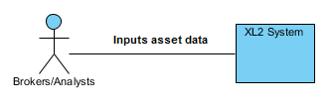
Figure 1: System Context diagram
Table 1: Actors summary
Actor | Description | Responsibilities
Brokers/analysts | Performs the analysis of the proposed property using the XL2 system | Compiles the costs and required development phases from the real estate developers and the funding sources from the investors in order to prepare the analysis and generate reports using the XL2 models

Artifacts & Information
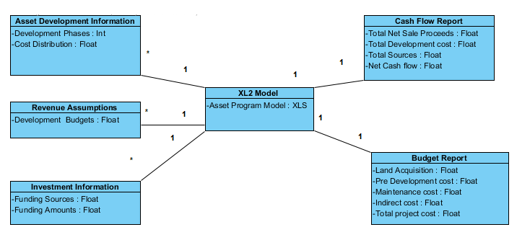
Figure 2: Artifacts and information diagram
Table 2: Artifacts and information summary
Artifact | Purpose
Asset Development Information | Convey to the analyst the costs and efforts required for the development of the asset
Revenue assumptions | Adjust budgets across each phase of the development process
Investment Information | Convey to the analyst the details of the different funding sources
XL2 Model | The populated template .xls file using the above input information to generate the calculated values based on the client’s model in order to generate reports
Budget report | This will enable the analyst to track the budget of the project over time.
Cash flow report | This will be the primary output report from the application. This will display an amount of values generated by the model in an easy to read format.

Behavior
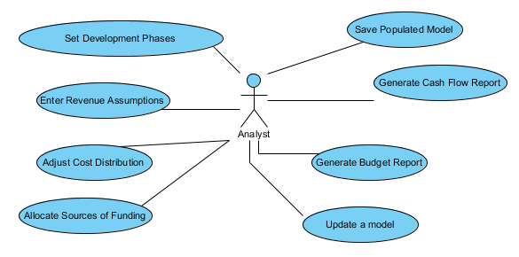
Figure 3: Process diagram

Enter Asset Information into the Model

Set Development Phases
Table 3: Process description (Set Development phases)
Identifier | Set Development Phases
Purpose | Determine the necessary development phases which will be modeled and how long they will be
Requirements | WC_1306, WC_1309, WC_1589, WC_1592, WC_1596
Development Risks | None
Pre-conditions | The analyst is in the Development Phase GUI tab
Post-conditions | The model will reflect the amount and length of development phases the analyst has chosen

Table 4: Typical course of action (Set Development phases)
Seq# | Actor’s Action | System’s Response
1 | Analyst enters which phases are required for this project into the GUI
2 |  | The system populates the phase names onto the client’s Excel templates

Table 5: Exceptional course of action (Set Development phases)
Seq# | Actor’s Action | System’s Response
1 | Analyst enters exceptional phases (like undefined phase names) into the GUI
2 |  | A window pops up stating that there was an error

Enter Revenue Assumptions
Table 6: Process description (Enter revenue assumptions)
Identifier | Enter Revenue Assumptions
Purpose | Input the revenue assumptions into the model in the appropriate phases
Requirements | WC_1306, WC_1309, WC_1589, WC_1593
Development Risks | None
Pre-conditions | The analyst is in the Revenue assumption GUI tab
Post-conditions | The system model is populated with the revenue assumptions entered by the analyst

Table 7: Typical course of action (Enter revenue assumptions)
Seq# | Actor’s Action | System’s Response
1 | Analyst enters Revenue Assumptions in the respective phases into the GUI
2 |  | System model is populated with the revenue assumptions

Table 8: Exceptional course of action (Enter revenue assumptions)
Seq# | Actor’s Action | System’s Response
1 | Analyst enters exceptional Revenue Assumptions (undefined type) into the GUI
2 |  | A window pops up stating that there was an error

Adjust the Costs Distributions
Table 9: Process description (Adjust the cost distributions)
Identifier | Adjust the Costs Distribution
Purpose | Populate the model with the appropriately distributed costs in the appropriate phases
Requirements | WC_1306, WC_1309, WC_1589, WC_1591, WC_1594, WC_1595
Development Risks | None
Pre-conditions | The analyst is in the Costs Distributions GUI tab
Post-conditions | The model has been populated with the costs distribution in the appropriate phases

Table 10: Typical course of action (Adjust the cost distribution)
Seq# | Actor’s Action | System’s Response
1 | The analyst enters the amount of the cost in the desired phase
2 |  | The model is populated with the costs distributed in the appropriate development phases

Table 11: Exceptional course of action (Adjust the cost distribution)
Seq# | Actor’s Action | System’s Response
1 | The analyst enters the exceptional amount of the cost (undefined type) in the desired phase
2 |  | A window pops up stating that there was an error

Allocate Sources of Funding
Table 12: Process description (Allocate sources of funding)
Identifier | Allocate Sources of Funding
Purpose | To generate different reports through the program model
Requirements | WC_1306, WC_1309, WC_1589, WC_1597, WC_1598, WC_1600,
Development Risks | None
Pre-conditions | The analyst is in the Sources of Funding GUI tab
Post-conditions | The system model is populated with the sources of funding

Table 13: Typical course of action (Allocate sources of funding)
Seq# | Actor’s Action | System’s Response
1 | The analyst specifies the sources of funding and the amount
2 |  | The model is populated with the sources of funding

Table 14: Exceptional course of action (Allocate sources of funding)
Seq# | Actor’s Action | System’s Response
1 | The analyst specifies the exceptional sources of funding and the amount (undefined type)
2 |  | A window pops up stating that there was an error

Save Populated Model
Table 15: Process Description (Sava populated model)
Identifier | Save Populated Model
Purpose | Save the populated model for recall later
Requirements | WC_1315, WC_1586, WC_1590, WC_1601
Development Risks | None
Pre-conditions | The analyst is in the File menu tab
Post-conditions | The system model is capable of being recalled since it is stored in a complete .xls Excel file

Table 16: Typical course of action (Sava populated model)
Seq# | Actor’s Action | System’s Response
1 | The analyst saves the completed model
2 |  | An .xls Excel file is generated from the model template to save the populated data

Table 17: Exceptional course of action (Sava populated model)
Seq# | Actor’s Action | System’s Response
1 | The analyst saves the completed model
2 |  | If there is an error in saving the file then a window pops up stating that there was an error in saving the file.

Update a Model
Table 18: Process description (Update a model)
Identifier | Update a Model
Purpose | Modify and update a currently existing file
Requirements | WC_1315, WC_1585, WC_1586, WC_1587, WC_1590, WC_1601
Development Risks | None
Pre-conditions | There is an already existing populated program model
Post-conditions | The system model is capable of being recalled since it is stored in a complete .xls Excel file

Table 19: Typical course of action (Update a model)
Seq# | Actor’s Action | System’s Response
1 | The analyst opens the already existing file and updates it either my manually tweaking the file or modify the values through the GUI
2 |  | The .xls Excel file updates itself based on the modification that the user does

Table 20: Exceptional course of action (Update a model)
Seq# | Actor’s Action | System’s Response
1 | The analyst saves the completed model
2 |  | If there is an error then a window pops up stating that there was an error in saving the file.

Produce Cash Flow Analysis

Generate Cash Flow Report
Table 21: Process description (Generate cash flow report)
Identifier | Generate Cash Flow Report
Purpose | To provide investment details as an input to the program model
Requirements | WC_1304, WC_1312
Development Risks | None
Pre-conditions | The XL2 model must be completely populated
Post-conditions | A report is generated for a reader-friendly view of the analysis

Table 22: Typical course of action (Generate cash flow report)
Seq# | Actor’s Action | System’s Response
1 | The analyst populates the model
2 | The analyst requests a cash flow analysis report
3 |  | A PDF of the cash flow analysis report is generated in the form specified by the client

Table 23: Exceptional course of action (Generate cash flow report)
Seq# | Actor’s Action | System’s Response
1 | The analyst populates the model
2 | The analyst requests a cash flow analysis report
3 |  | If there is a problem in PDF generation then an error message will pop up

Track Budgets

Generate Budget Reports
Table 24: Process description (Generate budget reports)
Identifier | Generate Budget Reports
Purpose | This will enable the analyst, investor or real estate developer to track their asset budgets over time
Requirements | WC_1308, WC_1312
Development Risks | None
Pre-conditions | The model must be completely populated
Post-conditions | A report in the form specified by the client is generated in order to display the budget. This can be revisited and updated over time

Table 25: Typical Course of Action (Generate Budget Reports – New Model)
Seq# | Actor’s Action | System’s Response
1 | The analyst requests a budget report for a newly populated model
2 |  | A budget report is generated in the form specified by the client

Table 26: Alternate Course of Action (Generate Budget Reports – Saved Model)
Seq# | Actor’s Action | System’s Response
1 | The analyst loads a previously saved model
2 | The analyst updates the model based on the time and resources which have changed
3 |  | An updated budget report is generated in the form specified by the client

Modes of Operation
XL2 works in only one mode of operation.

System Analysis Rationale
XL2 project is comprised of two subsystems:
1. Java swing GUI implementation which populates the client’s Excel file
2. Generation of different reports based on client’s populated Excel file

The first subsystem provides the user with a GUI that takes all the inputs that the user enters and populates the appropriate cells in the client’s Excel file. This GUI is implemented using Java swing library. The entered values are linked to the Excel file through apache POI library which enables us to represent the file as a “workbook” object which can be written and read to different cells and can finally be written as an .xls Excel file

The second subsystem generates different reports like cash flow report, budget report etc. using the populated Excel file (from subsystem 1) and produces these reports in the native Excel form.

Another important requirement of this project is that the entire XL2 project should be in the form of .exe file. So this is done by using Excelsior Jet.

Technology-Specific System Design

Design Overview

System Structure
Since XL2 project’s end result is going to be an executable file, there is no hardware component involved in it. Hence there is no need for a hardware component diagram.
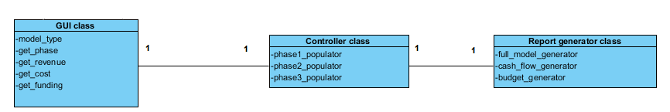
Figure 4: Software Component class diagram
Table 27: Software Component Description
Software Component | Description
GUI class | Interacts with the user and gets different data like model type, phase, revenue, cost and sources of funding. This uses java swing library in java for implementing the GUI
Controller class | Populates each and every entry of the client’s Excel file with the assimilated data. This uses apache POI library in java. A phase populator attribute populates that particular phase with revenue, cost and funding details
Report generator class | Generates cash flow report, budget report etc.

Design Classes

GUI class
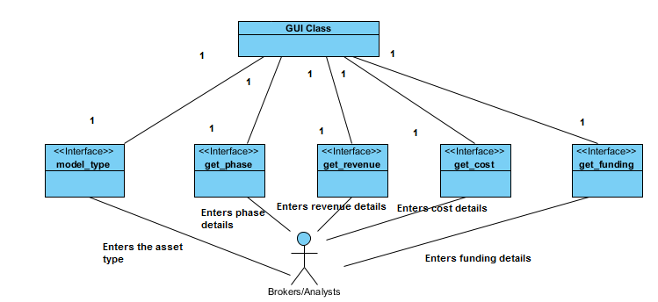
Figure 5: GUI class diagram
Table 28: GUI Class Description
Entity | Type | Description
GUI Class | Class | Assimilates all the data entered by the broker/analyst
model_type | Interface | Gets asset/model type from the analyst
get_phase | Interface | Gets phase detail from the analyst
get_revenue | Interface | Gets revenue details from the analyst
get_cost | Interface | Gets cost details from the analyst
get_funding | Interface | Gets sources of funding from the analyst
Brokers/Analysts | Actor | Enters the asset details into the XL2 system

Controller Class
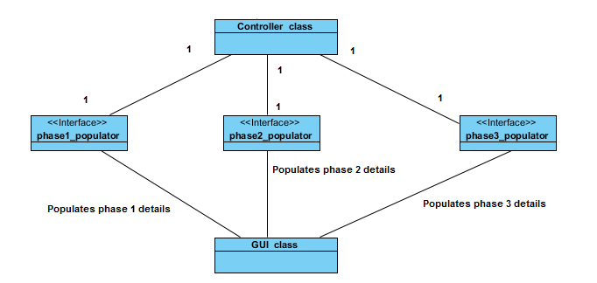
Figure 6: Controller class diagram
Table 29: Controller Class Description
Entity | Type | Description
Controller class | Class | Populates asset input data entered by the analyst into the Client’s Excel file template
phase1_populator | Interface | Gets phase 1 asset details
phase2_populator | Interface | Gets phase 2 asset details
phase3_populator | Interface | Gets phase 3 asset details
GUI class | Class | Assimilates all the asset details entered by the analyst

Report generator class
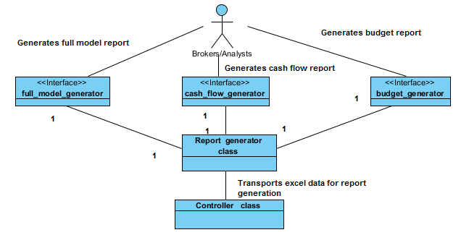
Figure 7: Report generator class diagram
Table 30: Report generator Class Description
Entity | Type | Description
Controller class | Class | Populates client’s Excel file with the input asset data
Report generator class | Class | Generates different types of reports
full_model_generator | Interface | Generates full model report
cash_flow_generator | Interface | Generates Cash flow report
budget_generator | Interface | Generates budget report
Broker/Analysts | Actor | End beneficiary of all the report generation

Process Realization
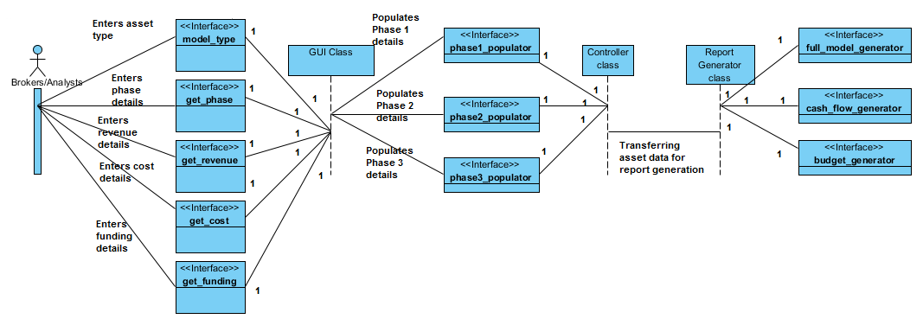
Figure 8: Process realization diagram

Design Rationale
As depicted in the software component diagram, the XL2 project has 3-tier architecture. This architectural style makes future changes to the system easier. The three tiers are listed below:
- GUI Class
- Controller Class
- Report Generator Class
The GUI Class allows the user to enter the asset data through a GUI implemented through java swing library. It takes model type, cost details, sources of funding, revenue details and phase details as input from the user.
The Controller Class uses the asset data obtained from the previous stage and populates the different cells of client’s Excel file template, which is used to generate different reports based on client’s program model. This uses apache POI library. Apache POI library has classes that represents the Excel files as workbooks. In workbook we have different sheets and there are rows and cells in each and every sheet which can be modified (either read or written).
The Report generator class produces different reports such as cash flow report, budget report, full build report etc. based on the populated Client’s Excel file template and produces these reports in .xls format.

Architectural Styles, Patterns and Frameworks

Table 31: Architectural Styles, Patterns, and Frameworks
Name | Description | Benefits, Costs, and Limitations
Three tier Architecture | The 3-tier architecture separates the application into 3 different layers: GUI Class, Controller Class, and Report generator Class. Each layer can only communicate with the layer immediately above or below itself (as explained in the design rationale). | This architecture is an Excellent example of separation of concerns principle: each layer is independent of the other. Therefore, any internal changes the layer do not affect other layers. As a result, a layer can be completely replaced with a different set of classes if required.  The main disadvantage of this architecture is the increase in the size of the project.

